Sun 30 Sep 12:17:06 PDT 2018

Using Xbee modules:

**Mouser #: 888-XB8-DMUS-002 $23**

**Mfr. #: XB8-DMUS-002**

**Desc.: RF Modules RF Modules XBee**

**865/868LP L.Pwr U.FL Ant 80kbps**

**Mouser #: 712-ANT-868-PW-QWUFL $8.11**

**Mfr. #: ANT-868-PW-QW-UFL**

**Desc.: Antennas Antennas 868MHz 1/4 Wave**

**Whip Permanent Mount, UFL**

Digi-Key $25

602-2108-ND

76000979

XBEE SMT GROVE DEVELOPMENT BOARD

Working to install Xbee SMT Grove Development board

Need FTDI Serial port drivers

Following instructions in



https://www.ftdichip.com/Support/Documents/AppNotes/AN_221_Adding%20an%20ADC_to%20a%20Raspberry_Pi.pdf

Downloaded:

libftd2xx1.1.12.tar.gz

But this command gives errors:

tar xfvz libftd2xx1.1.12.tar.gz

gzip: stdin: not in gzip format

tar: Child returned status 1

tar: Error is not recoverable: exiting now

Using

pi@raspberrypi:~/Downloads $ file libftd2xx1.1.12.tar.gz

libftd2xx1.1.12.tar.gz: POSIX tar archive (GNU)

I found that the file was NOT in gzip format despite the file name.

Instead I used:

pi@raspberrypi:~/Downloads $ tar -xvf libftd2xx1.1.12.tar

which suceeded.

Before installtion of drivers:

pi@raspberrypi:~ $ lsusb

Bus 001 Device 035: ID 03f0:a407 Hewlett-Packard

Bus 001 Device 034: ID 04ca:007d Lite-On Technology Corp.

Bus 001 Device 033: ID 0bda:5411 Realtek Semiconductor Corp.

Bus 001 Device 003: ID 0424:ec00 Standard Microsystems Corp. SMSC9512/9514 Fast Ethernet Adapter

Bus 001 Device 002: ID 0424:9514 Standard Microsystems Corp. SMC9514 Hub

Bus 001 Device 001: ID 1d6b:0002 Linux Foundation 2.0 root hub

After installation of drivers:

Bus 001 Device 041: ID 03f0:a407 Hewlett-Packard

Bus 001 Device 040: ID 04ca:007d Lite-On Technology Corp.

Bus 001 Device 039: ID 0bda:5411 Realtek Semiconductor Corp.

Bus 001 Device 003: ID 0424:ec00 Standard Microsystems Corp. SMSC9512/9514 Fast Ethernet Adapter

Bus 001 Device 002: ID 0424:9514 Standard Microsystems Corp. SMC9514 Hub

Bus 001 Device 001: ID 1d6b:0002 Linux Foundation 2.0 root hub

#

Apparently still not being recognized.... :-(

Reading over the instructions, I determined that the link in the file was not the latest by a long shot.

1.1.12 vs 1.4.8

So removing all the files from

/usr/local/lib

in the lib* files:

pi@raspberrypi:~/Downloads/release/build/arm926 $ ls -l /usr/local/lib/

total 480

-rw-r--r-- 1 root staff 241478 Sep 30 12:10 libftd2xx.a

lrwxrwxrwx 1 root staff 34 Sep 30 12:14 libftd2xx.so -> /usr/local/lib/libftd2xx.so.1.1.12

-rwxr-xr-x 1 root staff 229597 Sep 30 12:10 libftd2xx.so.1.1.12

drwxr-sr-x 3 root staff 4096 Sep 30 12:28 libusb

drwxrwsr-x 3 root staff 4096 Nov 28 2017 pypy2.7

drwxrwsr-x 4 root staff 4096 Nov 28 2017 python2.7

drwxrwsr-x 3 root staff 4096 Nov 28 2017 python3.5

Downloaded the file, and again had skip the gzip option because file was in tar not gzip format:

pi@raspberrypi:~/Downloads $ ls -l

-rw-r--r-- 1 pi pi 3645440 Sep 30 12:34 libftd2xx-arm-v6-hf-1.4.8.gz

drwxr-xr-x 5 pi pi 4096 Jun 14 08:31 release

Following the instructions in

pi@raspberrypi:~/Downloads/release $ vi ReadMe.txt

Hmm.

The readme says that this has been tested up to Raspian V7, but I am running Raspian V9.

Sun 30 Sep 13:27:52 PDT 2018

Still no joy. lsusb still does not show anything...

tried 3 different USB cables.

reboot.. no joy

sudo rmmod ftdi_sio

sudo rmmod usbserial

Wed 3 Oct 22:07:31 PDT 2018

IMPORTANT: I finally realized that the USB/Micro USB cables were consistent in all the attempts I made to communicate with SAMD21, USB relay card, and Xbee.

I ordered some new ones, AND THEY WORKED!

So all this time, the only reason I could not communicate with the

USB device was because all 4 Micro USB cable I have are

missing a data line!!

All four!?!?! Yep.

I bought 3 more and they work fine

I labelled the bad ones, except for the micro USB power cable with a

switch for the Rpi. It is clearly a power cable.

pi@raspberrypi:~/HHS $ lsusb

Bus 001 Device 058: ID 0403:6001 Future Technology Devices International, Ltd FT232 USB-Serial (UART) IC

Bus 001 Device 056: ID 03f0:a407 Hewlett-Packard

...

Sun 7 Oct 12:50:14 PDT 2018

Installed minicom to talk with Xbee

Set Com params to 9600 Baud, 8 data bits, no parity, no flow control

I can communicate with the Xbee!! Yay!

sending +++

returns OK

Then AT SL (Source address Low) gives

4187AD0C

AT SH (Source address High)

3A200

It seems to return out of command mode into

transparent mode rather quickly, <1 minute

I ordered another Xbee development card from Digikey,

so I should be able to test the RF links soon.

Sun 7 Oct 18:13:31 PDT 2018

installed xbee python libraries using

pip3 install digi-xbee

See:

https://xbplib.readthedocs.io/en/latest/getting_started_with_xbee_python_library.html#run-your-first-xbee-python-application

then

python3

These worked:

> from digi.xbee.devices import XBeeDevice

> device = XBeeDevice("/dev/ttyUSB0", 9600)

But then :

>device.open()

Traceback (most recent call last):

File "<stdin>", line 1, in <module>

File

"/home/pi/.local/lib/python3.5/site-packages/digi/xbee/devices.py", line

1259, in open

raise InvalidOperatingModeException("Could not determine operating

mode")

digi.xbee.exception.InvalidOperatingModeException: Could not determine

operating mode

>>>

I think that this may be because I have not setup the device yet using

XCTU. It appears that XCTU does not run on Raspberry Pi, so I will have

to set up the devices on my PC, then move them to the Pi.

10/8/18 21:05:58

Installed XCTU on PC. Connected to Xbee & configured, but only partly since I cannot test with another Xbee and esablish a link yet.

Reconnected to Rpi and tried to open device on configured Xbee. No joy. Same error.

10/10/18 22:34:54

Received second SMT Grove development board.

Noticed that Digi also makes a small board that holds an Xbee with interface chips and a 0.1 grid pin connector.

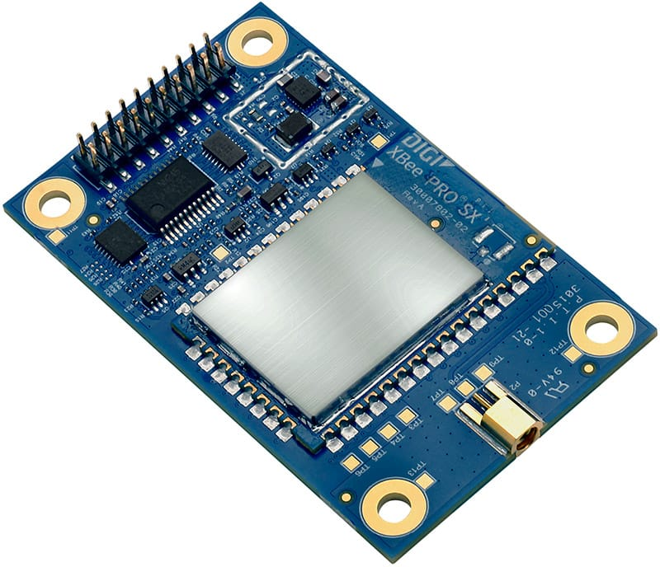

<https://www.digi.com/products/xbee-rf-solutions/sub-1-ghz-modules/xtend-module>

I have not figured out what this board is or does or how to order it, but it looks very useful. This is probably the way we want to launch the Xbee in the rocket.

Xbee Python library docs

<https://xbplib.readthedocs.io/en/stable/>

XBee_A

SH = 13A200

SL = 4187AD0C

Xbee_B

SH = 13A200

SL = 4187AC85

Followed these directions and successfully configured the two modules to talk to each other!

<https://www.digi.com/resources/documentation/digidocs/90001526/tasks/t_configure_remote_xbee_modules.htm>

Used minicom on /dev/ttyUSB0 to send a message to home device at 9600 8N1 baud

“this is a test”… It worked!!

Received by PC connected Xbee running XCTU

10/14/2018 9:04 PM

I realized that I need to use python on my desktop PC to talk to the attached Xbee module

So I installed Python3-32.

To install modules need command:

C;\Users\Rick\AppData\Local\Programs\Python\Python37-32>python –m pip install –upgrade pip

C;\Users\Rick\AppData\Local\Programs\Python\Python37-32>python –m pip install serial

Still need to fix windows paths for python

10/15/2018 10:15 PM

Got the xbee to read the received string data correctly on the PC:

counter=0

try:

ser = serial.Serial('COM3')

except serial.serialutil.SerialException:

ser.close()

ser = serial.Serial('COM3')

while 1:

ser_text = ser.readline().decode('ascii').rstrip()

outline = str(counter) + ': ' + str( ser_text )

print (outline)

# print (dump(str(ser_text)))

counter += 1

Gives:

…

481: Write counter: 481

482: Write counter: 482

483: Write counter: 483

….

The “decode” is necessary to change the binary string into a python string. The rstrip chops off the newline that is necessary on the transmit side to get the xbee to transmit a line and the receiver to read a line. No longer necessary to print out since python puts a newline on every print statement.

I am exclusively using transparent mode on both TX and RX.

I think that we will not be able to use transparent mode if we want to interleave ADC samples in the middle of the transactions. This looks like it might be a REAL pain since it seems that the XBEE API python code on the Raspberry pi errors out every time I try it.

Perhaps we can just use the API mode on the PC end … Need to test digi-xbee API on the PC to see if it works there.

10/15/2018 10:41 PM

Changed PC module to [AP] API mode without escapes[1] using XCTU.

IMPORTANT: It turns out, EVERY time I change from XCTU to Python or back, I have to disconnect the XBEE USB cable from the front of the PC to reset and/or release the COM3 serial port. This factoid cost me hours of messing around.

On PC, the API works:

>>> from digi.xbee.devices import XBeeDevice

>>> device = XBeeDevice("COM3", 9600)

>>> device.open()

No errors! The API works on my PC! (Windows 10), under Python3

Not sure if the Rpi version will ever work…. Hmmm.

Maybe we should just write to code on the PC.

There is a way to read ADC values remotely from the remote Xbee.

10/16/2018 7:58 PM

Path to the examples:

Are on github here:

<https://github.com/digidotcom/python-xbee/blob/master/examples/>